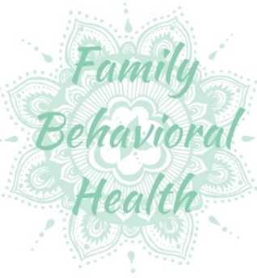
Step One
Frequently asked
questions:

Who can refer a client?
(A) Anyone can refer a client to FBH. Potential clients can self-refer or give us a call to get started.
Do I have to complete the entire referral form?
- No, only complete as much as you can. The remaining sections will be completed during intake.
What happens if the client does not meet eligibility?
- We will notify the family and make recommendations and or referrals to other community services that may be helpful.
Can a client only utilize your assessment services and not utilize other services?
- Yes, it is the client’s/guardian’s right to choose to engage in treatment.
In the case of a social worker as a guardian, does the guardian have to be present during the assessment and or treatment sessions?
- No, however the social worker will have to sign and authorize treatment and authorization to release information to work with foster parents.

Complete a referral form found online under the “Contact Us” tab of our website and then click on “Referral.” Once you have completed the form, simply click “Submit” at the bottom of the page. Printable forms are available under the “Downloads” tab of our website and can be sent to us either as an attachment to Info@fbhnv.com or by fax at (775) 525-3889.
Step Two
When we receive the referral form, we will verify eligibility. Once cleared we will contact the client or client’s guardian in the case of a minor to schedule the initial assessment. Assessments are completed over 2 to 3, 50 min sessions. Prior to the assessment we ask that the guardian provide us with information and documentation that would be useful for the assessment. In addition, we will request written authorization from the guardian to collect pertinent documentation: i.e. IEP, past psychiatric assessments, other testing, and medical records etc.
Step Three
After the assessment the clinician will determine eligibility for a mental health diagnosis as well as recommendations for treatment i.e. Therapy and Rehabilitation services etc. Based on the recommendation and the client’s/guardian’s approval we would begin services which may or may not require a prior authorization. An individualized treatment plan is developed with the client and stakeholders and services will begin.
  - Website: familybehavioralhealth.weebly.com
  - Link to services provided:
www.fbhnv.com
Address: 438 Pyramid Way Sparks, NV 89431
Phone: 775-378-2775

